Exercise 2: Implementing Dependency Injection
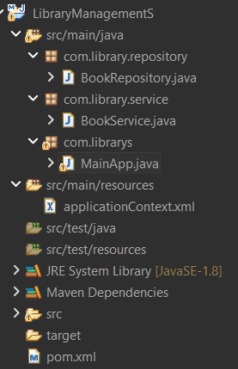

package com.library.repository;

public class BookRepository {

public void saveBook() {
System.out.println("Book saved in repository");
}
}

package com.library.service;

import com.library.repository.BookRepository;

public class BookService {

private BookRepository bookRepository;

public void setBookRepository(BookRepository bookRepository) {
this.bookRepository = bookRepository;
}

public void addBook() {
System.out.println("Service layer: adding book...");
bookRepository.saveBook();
}
}

package com.librarys;

import org.springframework.context.ApplicationContext;
import org.springframework.context.support.ClassPathXmlApplicationContext;
import com.library.service.BookService;

public class MainApp {

public static void main(String[] args) {

ApplicationContext context =
new ClassPathXmlApplicationContext("applicationContext.xml");

BookService service =
(BookService) context.getBean("bookService");

service.addBook();
}
}

<?xml version="1.0" encoding="UTF-8"?>
<beans xmlns="http://www.springframework.org/schema/beans"
xmlns:xsi="http://www.w3.org/2001/XMLSchema-instance"
xsi:schemaLocation="
http://www.springframework.org/schema/beans
http://www.springframework.org/schema/beans/spring-beans.xsd">

<bean id="bookRepository" class="com.library.repository.BookRepository"/>

<bean id="bookService" class="com.library.service.BookService">
<property name="bookRepository" ref="bookRepository"/>
</bean>

</beans>

<project xmlns="http://maven.apache.org/POM/4.0.0"
xmlns:xsi="http://www.w3.org/2001/XMLSchema-instance"
xsi:schemaLocation="
http://maven.apache.org/POM/4.0.0
http://maven.apache.org/xsd/maven-4.0.0.xsd">

<modelVersion>4.0.0</modelVersion>

<groupId>com.library</groupId>
<artifactId>LibraryManagementS</artifactId>
<version>1.0</version>

<dependencies>

<dependency>
<groupId>org.springframework</groupId>
<artifactId>spring-context</artifactId>
<version>5.3.9</version>
</dependency>

</dependencies>

</project>

OUTPUT:
